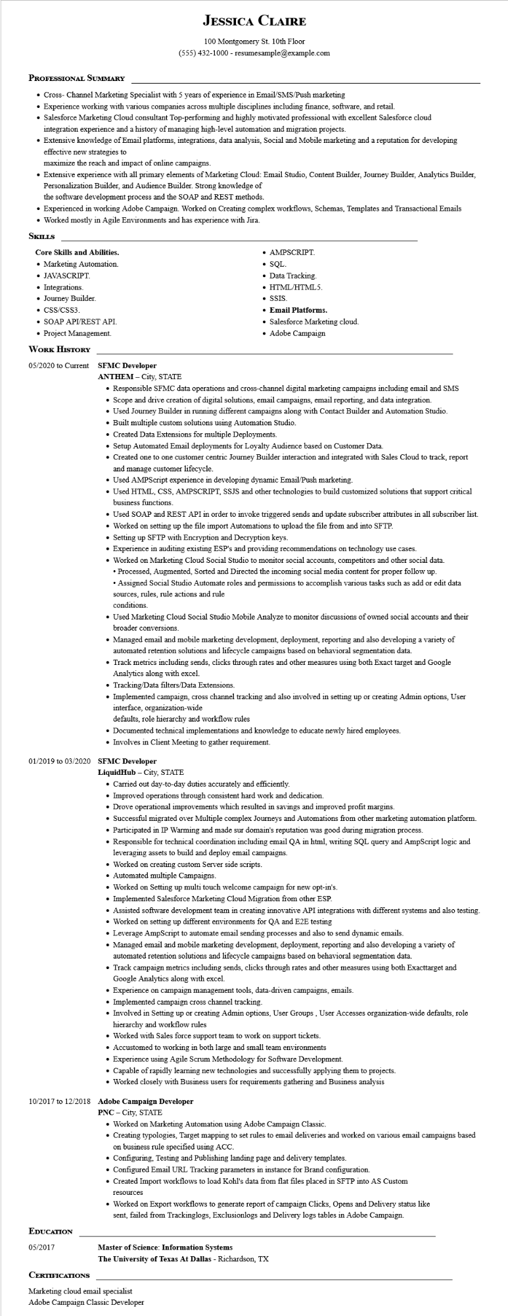
JESSICA CLAIRE
100 Montgomery St. 10th Floor
(555) 432-1000 - resumesample@example.com
PROFESSIONAL SUMMARY
• Cross- Channel Marketing Specialist with 5 years of experience in Email/SMS/Push marketing
• Experience working with various companies across multiple disciplines including finance, software, and retail.
• Salesforce Marketing Cloud consultant Top-performing and highly motivated professional with excellent Salesforce cloud
integration experience and a history of managing high-level automation and migration projects.
Extensive knowledge of Email platforms, integrations, data analysis, Social and Mobile marketing and a reputation for developing effective new strategies to
maximize the reach and impact of online campaigns.
• Extensive experience with all primary elements of Marketing Cloud: Email Studio, Content Builder, Journey Builder, Analytics Builder, Personalization Builder, and Audience Builder. Strong knowledge of
the software development process and the SOAP and REST methods.
• Experienced in working Adobe Campaign. Worked on Creating complex workflows, Schemas, Templates and Transactional Emails • Worked mostly in Agile Environments and has experience with Jira.
SKILLS
Core Skills and Abilities.
• Marketing Automation.
• JAVASCRIPT.
• Integrations.
• Journey Builder.
• CSS/CSS3.
• SOAP API/REST API.
• Project Management.
WORK HISTORY
05/2020 to Current SFMC Developer ANTHEM - City, STATE
• AMPSCRIPT.
• SQL.
• Data Tracking.
• HTML/HTML5.
•SSIS.
• Email Platforms.
• Salesforce Marketing cloud.
• Adobe Campaign
• Responsible SFMC data operations and cross-channel digital marketing campaigns including email and SMS
• Scope and drive creation of digital solutions, email campaigns, email reporting, and data integration.
• Used Journey Builder in running different campaigns along with Contact Builder and Automation Studio.
• Built multiple custom solutions using Automation Studio.
• Created Data Extensions for multiple Deployments.
• Setup Automated Email deployments for Loyalty Audience based on Customer Data.
• Created one to one customer centric Journey Builder interaction and integrated with Sales Cloud to track, report and manage customer lifecycle.
• Used AMPScript experience in developing dynamic Email/Push marketing.
• Used HTML, CSS, AMPSCRIPT, SSJS and other technologies to build customized solutions that support critical business functions.
• Used SOAP and REST API in order to invoke triggered sends and update subscriber attributes in all subscriber list.
• Worked on setting up the file import Automations to upload the file from and into SFTP.
• Setting up SFTP with Encryption and Decryption keys.
• Experience in auditing existing ESP's and providing recommendations on technology use cases.
• Worked on Marketing Cloud Social Studio to monitor social accounts, competitors and other social data.
• Processed, Augmented, Sorted and Directed the incoming social media content for proper follow up.
• Assigned Social Studio Automate roles and permissions to accomplish various tasks such as add or edit data sources, rules, rule actions and rule
conditions.
• Used Marketing Cloud Social Studio Mobile Analyze to monitor discussions of owned social accounts and their broader conversions.
• Managed email and mobile marketing development, deployment, reporting and also developing a variety of automated retention solutions and lifecycle campaigns based on behavioral segmentation data.
• Track metrics including sends, clicks through rates and other measures using both Exact target and Google Analytics along with excel.
• Tracking/Data filters/Data Extensions.
• Implemented campaign, cross channel tracking and also involved in setting up or creating Admin options, User interface, organization-wide
defaults, role hierarchy and workflow rules
• Documented technical implementations and knowledge to educate newly hired employees.
• Involves in Client Meeting to gather requirement.
01/2019 to 03/2020 SFMC Developer
LiquidHub - City, STATE
• Carried out day-to-day duties accurately and efficiently.
• Improved operations through consistent hard work and dedication.
• Drove operational improvements which resulted in savings and improved profit margins.
• Successful migrated over Multiple complex Journeys and Automations from other marketing automation platform.
• Participated in IP Warming and made sur domain's reputation was good during migration process.
• Responsible for technical coordination including email QA in html, writing SQL query and AmpScript logic and leveraging assets to build and deploy email campaigns.
• Worked on creating custom Server side scripts.
• Automated multiple Campaigns.
• Worked on Setting up multi touch welcome campaign for new opt-in's.
• Implemented Salesforce Marketing Cloud Migration from other ESP.
• Assisted software development team in creating innovative API integrations with different systems and also testing.
• Worked on setting up different environments for QA and E2E testing
• Leverage AmpScript to automate email sending processes and also to send dynamic emails.
• Managed email and mobile marketing development, deployment, reporting and also developing a variety of
automated retention solutions and lifecycle campaigns based on behavioral segmentation data.
• Track campaign metrics including sends, clicks through rates and other measures using both Exacttarget and Google Analytics along with excel.
• Experience on campaign management tools, data-driven campaigns, emails.
• Implemented campaign cross channel tracking.
• Involved in Setting up or creating Admin options, User Groups, User Accesses organization-wide defaults, role hierarchy and workflow rules
• Worked with Sales force support team to work on support tickets.
• Accustomed to working in both large and small team environments
• Experience using Agile Scrum Methodology for Software Development.
•Capable of rapidly learning new technologies and successfully applying them to projects.
• Worked closely with Business users for requirements gathering and Business analysis
10/2017 to 12/2018 Adobe Campaign Developer
EDUCATION
05/2017
CERTIFICATIONS
PNC - City, STATE
• Worked on Marketing Automation using Adobe Campaign Classic.
• Creating typologies, Target mapping to set rules to email deliveries and worked on various email campaigns based on business rule specified using ACC.
• Configuring. Testing and Publishing landing page and delivery templates.
• Configured Email URL Tracking parameters in instance for Brand configuration.
• Created Import workflows to load Kohl's data from flat files placed in SFTP into AS Custom
resources
• Worked on Export workflows to generate report of campaign Clicks, Opens and Delivery status like
sent, failed from Trackinglogs, Exclusionlogs and Delivery logs tables in Adobe Campaign.
Master of Science: Information Systems
The University of Texas At Dallas - Richardson, TX
Marketing cloud email specialist
Adobe Campaign Classic Developer

